Stewards Pooi Kei Primary School
Name: Genesee Ng ( 22) Class: J.2 Hope Date: 3rd January, 2021

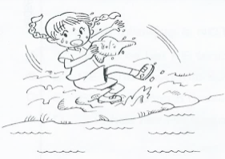
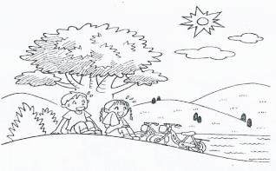
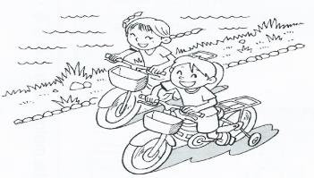
A Story
?

It is a scorching day. Fred and Sally are at the country park riding their bicycles by the river in Tai Po. They are elated because they get excited going out by themselves.

As they are riding bikes, they decide to take a rest. Then they see an old oak tree, under which there is a shady, spacious spot. They get off their bikes and sit on the grass under the tree. They are exhausted after cycling for fours. They feel a sense of relief there. Sally takes out a face cloth to wash her sweaty face. She wants to wash her face in the river.

Suddenly, Sally slips on the ground and falls into the river. She feels scared and yells for Fred. Fred quickly runs to her. He pulls her out from the water and dries her with a towel.

Sally is safe now and she feels grateful for Fred’s help. After everything is settled, they finally have a picnic under the tree. They feel happy at the end.

